Install XAMPP
First, you should visit XAMPP download page and download XAMPP script. At the time writing this tutorial the latest XAMPP version is 7.3.0. You can visit their download page if the new version is available.
To download XAMPP run following command in the terminal:
sudo wget https://downloadsapachefriends.global.ssl.fastly.net/7.3.0/xampp-linux-x64-7.3.0-0-installer.run?from_af=true
Now make the downloaded file executable by setting permissions to file:
sudo chmod +x xampp-linux-x64-7.3.0-0-installer.run
After setting up the permission run the file using the following command.
sudo ./xampp-linux-x64-7.3.0-0-installer.run
You will get the following screen then click on next.
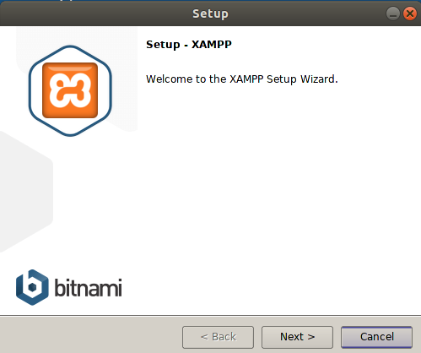
Now it will ask you to select components to install, it is recommended to leave it as default and click on Next.
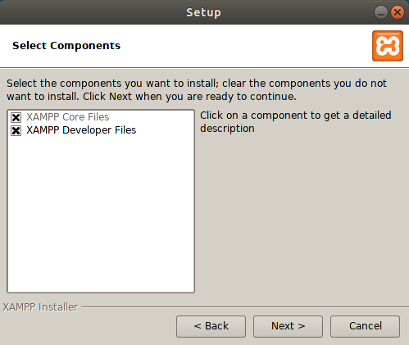
In this step, you will be informed of the location where the XAMPP setup is going to be installed. Click on Next
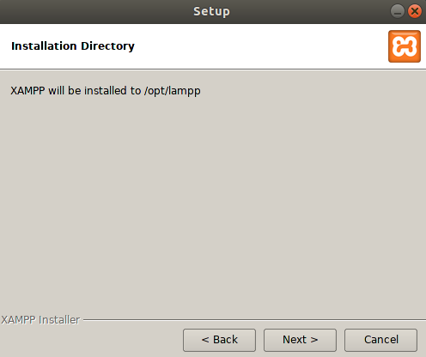
Now it will ask you to install sponsored applications such as Drupal, Joomla, and WordPress. You can uncheck checkbox if you don’t want these applications should be installed. Then click on Next button.
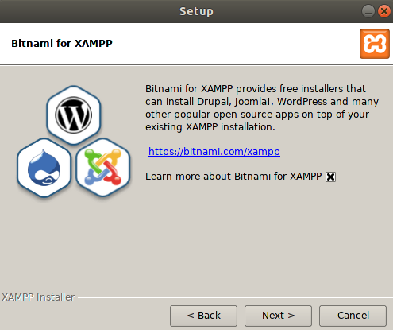
Now you should click on Next button.
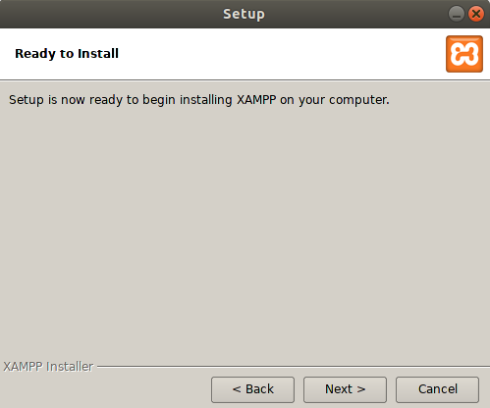
Here the installation process is started.
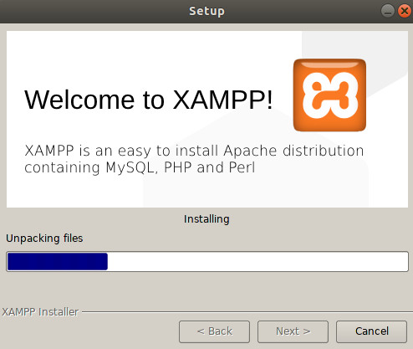
After completing installation click on Finish to complete the setup.
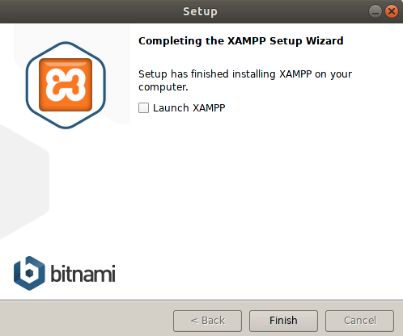

Start and Verify XAMPP installation
Stating XAMPP in Linux Mint is very much easy. To start XAMPP form terminal on Linux Mint run following command.
$ sudo /opt/lampp/lampp start
Now visit http://localhost/ to see XAMPP output screen.
To visit PHPMyAdmin visit following link http://localhost/phpmyadmin/
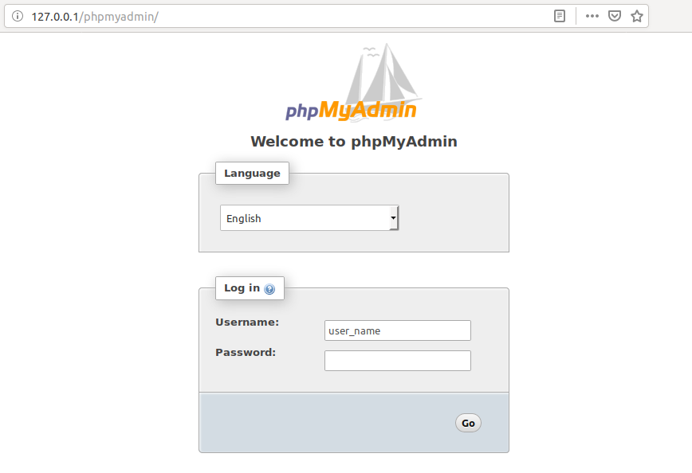

Uninstall XAMPP
To uninstall XAMPP first navigate to /opt/lampp directory.
cd /opt/lampp
Now start uninstallation process running following command:
./uninstall
Now you will be prompted to confirm uninstalling XAMPP. Click on Yes to uninstall XAMPP.
After completing the Uninstallation process run following command to remove /opt/lampp directory.
sudo rm -r /opt/lampp

